wailea808
www.808wailea.com
469-733-5972
90 Kai La Place, Wailea HI 96753
  - Volume 1 / Issue 1
  - RECENT Wailea808 PRESS RELEASE
Our organization is driven by a passion for creating a future where progress aligns with the values of our community. Through advocacy, education, and collaboration, we aim to shape policies and practices that benefit the present and future generations. Wailea808 invites you to join us in our journey towards a more harmonious and conscious approach to development.
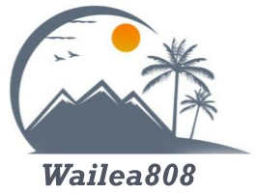
Tap here to add a caption
  - “We must treat Maui’s aquifers, streams, and springs as living partners in our future — planning every new home, resort, and road so that growth never comes at the cost of the source waters that sustain this island.”
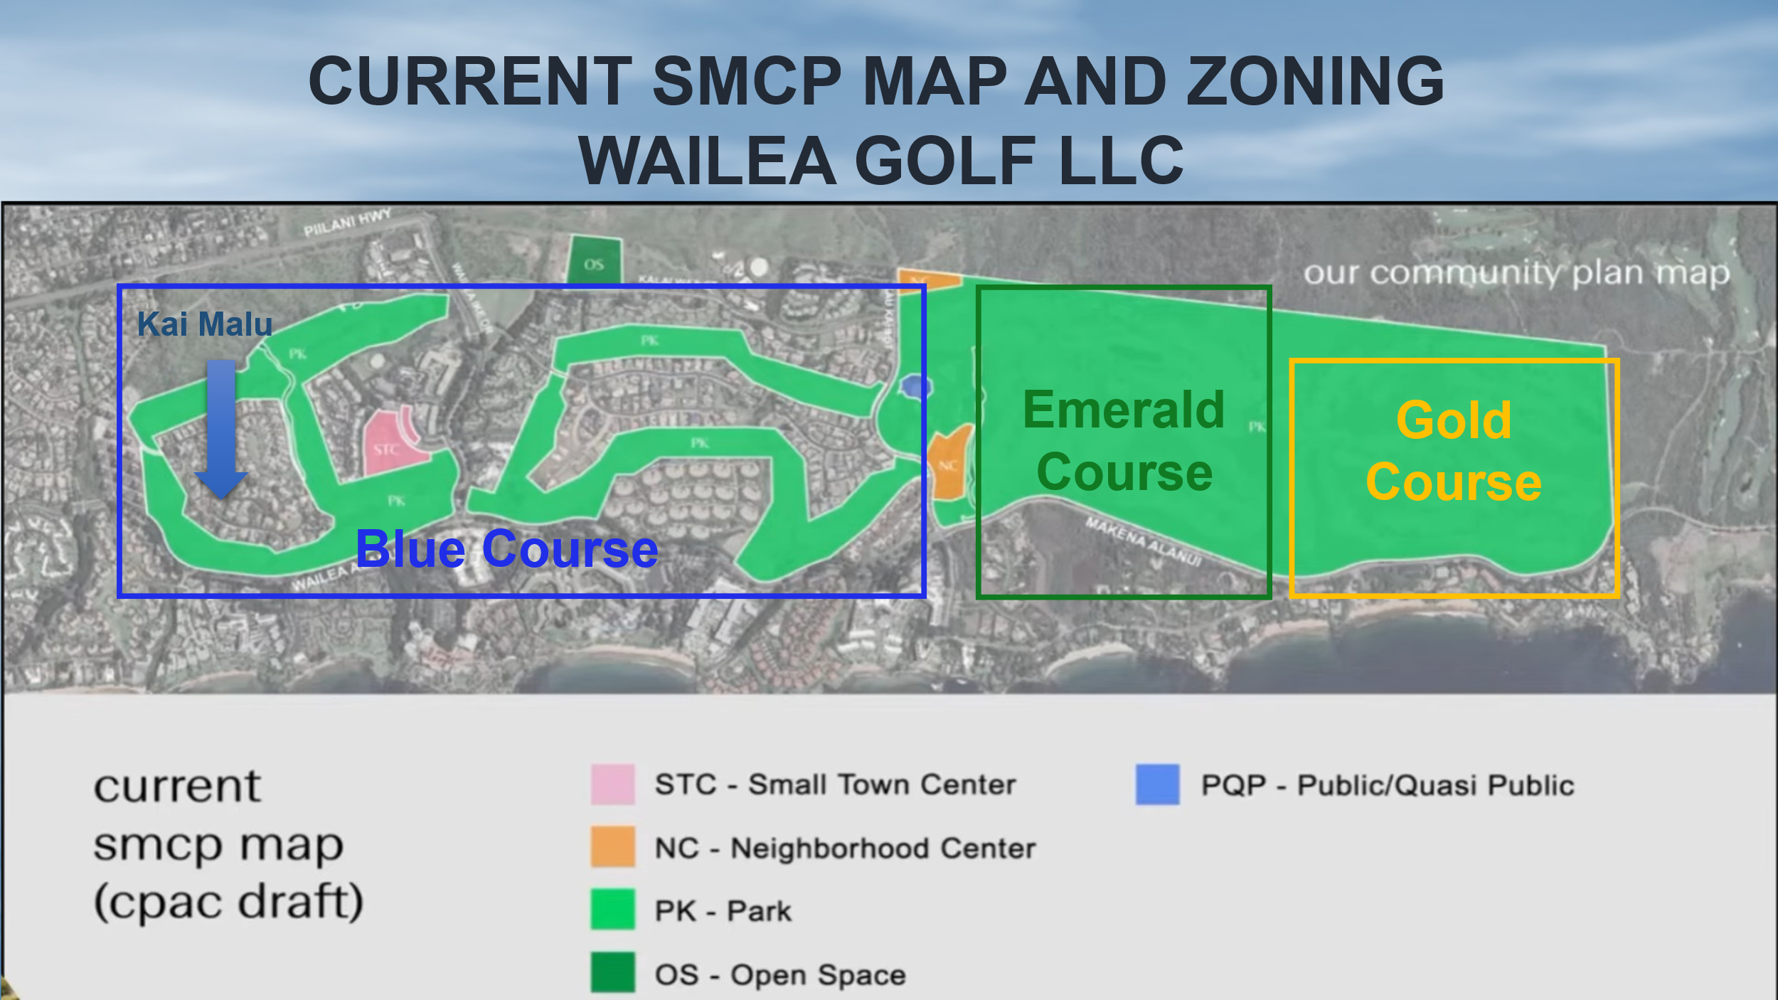
  - WAILEA808 IS FIGHTiNG ON SEVERAL FRONTS TO STOP THE REDEVELOPMENT OF THE wAILEA GOLF COURSES. wE NEED YOUR HELP!
We engaged a legal firm in December to assist in our efforts to retain the open spaces, amenities, peaceful, quiet resort we all were promised when we purchased in this Master Planned Resort Community. You can help by supporting us with DONATIONS to continue our efforts.
We also need volunteers for individuals that have web and social media experience, communications skills, marketing, and fund-raising capabilities. Our Treasurer is stepping down soon as he received a promotion so anyone with accounting capabilities would be helpful.
